The Ministry of Education
First Exam
Name: ............................................................................................................................. Class: 3 Th Grade
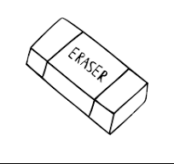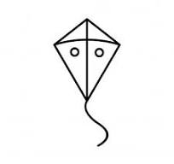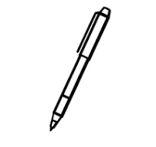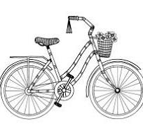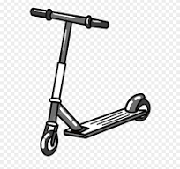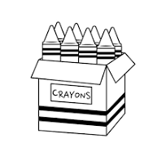
k_
rubber a scooter pen crayons kite bike

******************************************************************************************
Those are | These are | That is | This is

……………………. .. ……………………….. …………………………… …………………………..

**********************************************************************************************************
13 16 15 17 14

thirteen fourteen fifteen sixteen seventeen

*******************************************************************************************
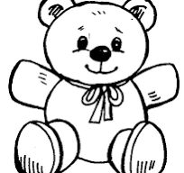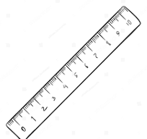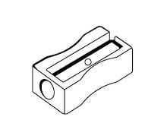

plane bear sharpener ruler

P c x n t h v

a | b |  | d | e | f | g |  | i | j
k | l | m |  | o |  | q | r

s |  | u |  | w |  | y | z

