The Ministry of Education
Second Exam
Name: ........................... ___ . Class: 3 Th Grad
Arabic meaning :- ★
1- reading abook …………………..
2-setting the table ……………………
-using the computer ………………
-sending an email …………………..4
5-writnig aletter ……………
writing | sending | Learning | using | reading | setting
- I'm ……………………a book .1
2- I'm ……………………. a letter .
- I'm …………………….the table .3
- I'm ……………………..the computer .4
-I'm ……………………an email .5
6- I'm ………………….. about Jordan .
Write with capital letters :- ★
1- mum is cooking
………………………………………….……..
2- dad is reading about jordan
…………………………………………………..
3- issa is hellping mum
……………………………………………………
4- alia is writing
……………………………..…………………….
- she write about amman and aqaba
…………………………………………………………

5
Dear Laila and Ali ,
We're going to Aqaba ,Dad is driving . We aredriving through the mountains . We are visiting Hammamat Ma'in . There is avery big waterfull .The water is very warm . The sky is blue ,We are swimming and playing in the water in Hammamat Ma'in . Here is a pgoto .
Samira and Kareem

1) The family is travelling to Aqaba by car/ plane.
2) There is / isn’t a waterfall at Hammamat Ma’in.
3) The water is warm / cold.
4 )Kareem and Samira are swimming in the water/reading about the waterfall .
5) Kareem and Samira are looking at / sending a photo
Arabic meaning :-
1- visiting the waterfull …………………….
2- driving through the mountain ………………………
3- going to Aqaba ……………………………
4- swimming in water warm ………………………………
★Match the word with the pictures :-
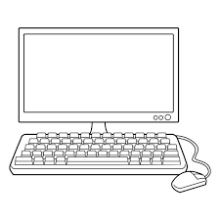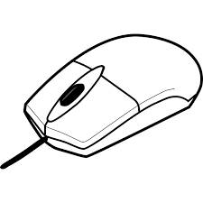
Mouse Computer Monitor Printer keyboard
. / ? ))
1-This is our diary
-Do you write a diary 2
-We are learning 3
Q3)- Write and use capitals? (6 points)
1- issa is helping mum
2- dad is reading about jordan
Dear Grandma and Grandpa ,
We're in aqaba ! We 're staying in a hotel by the sea . We'r at theMarine Park on the beach . We aren't swimming . We're looking at fish and a turtule . The turtle isn't swimming . It's sleeping ! Mum is buying somebook.
Samira and Kareem

1) Where are Samira and Kareem? ………………………………………………….
2) Where are they stay ?............................
4) What are Samira and Kareem looking at ? …………………………………………….
5) Is the turtle swimming ? ………………………………………………………………..
6) Is Mum looking at the fish ? …………………………………………………………….

always | use | swimming | warm

1.)The water is …………………… in Hammamat Ma’in.
2.) Kareem is good at …………………………… .
3.)I ……………………. do my homework after school.
? / .
1) This is our diary
2) Do you write a diary
3) We are learning about Aqaba
4) Our school project is about Jordan
5) Do you like sailing
Copy and complete with the punctuation: (capitals, .or ?) (4 points):
- i always do my homework 1-

2-alia and muna
bl / fl / cl ) (
……ying 2… imb 3 ….. ue
★Order and write :-
1-are / a/ boat / waiting / We / for
…………………………………………………………………..
2-fast / boat / The / sailing / isn't.
……………………………………………………………………
3-is/the/dolphins / making / a / video / Kareem / of
……………………………………………………………………………………
Read then match :- ★
1) Are they waiting for bus? (a) No, she isnt.
2) Is he taking some photos? (b) No, it isn't .
3) Is the shark playing with the fish ? (c) No, they arn't .
4) Is she phoning her mother ? (d) No,he isn't
5) Are you healthy ? (e) Yes, I'm
Read then complete the sentences :- ★
- 1) Is Samira's mother visiting the museum?
No , …………………………………….
2) Is Kareem's father playing tennis ?
No, ………………………………………
3) Is Kareem swimming ?
Yes , ………………………………….
4) Is Samira writing postcards ?
No , ………………………………….
5) Is Grandma reading a postcard ?
Yes , …………………………………
read | send | watched | played
- 1) Khalid ----------------abook
2 2) Faris ---------------the letter .
3- 3) Mansour--------------tennis.
4- 4) Khaldoun ------------------to music.

Q3- Punctuate the following sentences.

ali likes going to amman
………………………………………………..
2) what are you doing
………………………………………………………………
Q4: Match the following questions with answers.
1-What is your name? a- I am 10 years old
2-How old are you? B-I am fine thank you
3-What are you good at? C- My name is Hamad
4- How are you? D- I am good at English.
____________________________________________________________________________
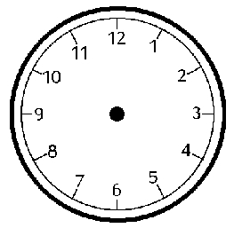
It's ten o'clock It's quarter to eight It's half past three It's quarter past one
★ Circle the right answer : ( 5 points)
1)-A tree is ……… a flower.
a-taller than b- short c-tall
2)- A wolf is………….a dog.
a-playing b- more dangerous c-dangerous
3)- We ………………. Do our homework.
a-swim b-always c-never
4)-The dolphins are …………………
a-jumping b-jump c-playing
5)- Dad …………. Travelling by car. a-is b-are c-am
★Read and write . (3points)
a.) What is your favorite sport ?
…………………………………………………………………..
b. )What are you going to do at the weekend?
……………………………………………………………………
Q5) – Order and write sentences. (6 points)
1-) favourite / day / My / Friday / is
. ……………………………………………………………………….
2-) fast / boat / The / sailing / isn't.
…………………………………………………………………………..
3-)drink / I / always / milk.
…………………………………………………..…………………….
★ Read and Write :
is are am
1-I --------- making a video .
2-They --------- playing football.
3-She -------- writing an email.
4 –Ibrahim ----------- watching television.
To: Ali and Laila
We're going to go to Deir Alla ! Deir Alla is west of Amman .At my uncle's farm, we're going to see the animals! Then, we're going to have a picnic at the Yarmouk River. After this, we're going to visit the old Roman Theatre at Umm Qais . Kareem and Samira
- Who wrote this letter?......................
- To whom?.................
- Where is Deir Alla ? : It’s (north / west) of Amman.
- They going to visit the old Roman Theatre. ( right / wrong)
5)The underlined word- picnic - means……………………
East | West | South | North
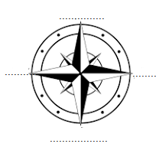
draw | farm | Plant | Pick | Sun hat

1) We'r going to visit ……………..in Deir Alla .
2)We'r going to ……….aubergines .
3) We'r going to ……………… fruit,
4) I'm going to ……………………pictures.
5)I'm going to take my …………………………
br cr dr

……ayon …..aw ….. ush
Arabic meaning :_
1) farm………………………
2) plant aubergines……………….
3) chicken………………………
4 ) tomatoes…………………….
5) pick fruit……………………
6)sun hat ……………………….
chickens | sun hat | farm | tomatoes

1)We're going to visit a ……………………
2)We're going to see the …………………
3)I'm going to plant …………………..
4I'm going to take my ……………………..
Arabic meaning :-
1) go to the sport center ……………….
2 )go to the library……………………….
3)pray at themosque…………………..
4)use the computer …………………..

★Write and use capital :-
1) dear ali and laila
……………………………………………………………
2)dier alla is westamman
…………………………………………………………….
3) we'r going to roman theatre at um qais
…………………………………………………………….
4)kareem and samira
……………………………………………………………
A: What are you going to do on Saturday ?
B : ………………………………………………………………….
We're going to go to Deir Alla ! Deir Alla is west of Amman .At my uncle's farm, we're going to see the animals! Then, we're going to have a picnic at the Yarmouk River. After this, we're going to visit the old Roman Theatre at Umm Qais .
Kareem and Samira

1)Who wrote this letter?................
2)To whom?...................
3)Where is Deir Alla ? : It’s (north / west) of Amman.
4)They going to visit the old Roman Theatre. ( right / wrong)
5)The underlined word- picnic - means……………………

★Fill in the blanks with the correct word : (5 points)
Islamic Education - driving- football - vegetables - email

1-I am going to play ………………..…..
2-Fatima is writing an …………………….
3-We are ……………………. through mountains.
4-My favorite subject is …………………….. .
5-They are going to plant………………………
Arabic meaning :-
travelling ………..walking up……………………step……………….
top……………Castle ………..
**************************************************************************************************************
1) We usually go to the market a)a photo of us!
2) Uncle Hassan is taking b) to Ajloun .
3 ) He is standing c) the steps .
4 ) Today we're travilling d) at the top of the castle
5) Uncle Hassan is walking up e) to the library
6) We usually go f) on Saturday .
___________________________________________________________________________
Usually +
فعل مجرد
1) I usually ………………. Lots of photo .( take / taking )
Now + ing
2) I'm …………………….. aphoto now ( take / taking )
3) I'm ………………………..up the steps now!
4) We usually ………………….to school .
**************************************************************************************************************
top | century | bridge | steps | room | gate
1) The castle fromm the twelfth …………………….
2) I'm walking across the ………………………
3) Now I'm going through the ……………………
4) This is my favourit ……………….. in the castle .
5) I'm walking up all the …………………..
6) Now I'm looking down from the …………………………….
_____________________________________________________________________________
1)I usually ……………..( deink / drinking ),
Today + ing
2) Today I'm …………………….( cook / cooking)
3 ) Now I'm ……………………( play / playing ).
**************************************************************************************************************
1) What do you usually do? ( ) I'm cooking.
2)What are you doing now? ( ) I usually play.
3)What are you going to do ? ( ) I'm going to play sport
4 )Are you playing football ? ( ) Yes I'm
tr / tw
…..ee / elfth
Arabicc meaning :-
squirrels……………… deer………………… forest………………green………………… trees………… prety prettier autumn…………… wolves……………fox…………….jackal…………………… frightened……………………… dangerous……………………
_____________________________________________________________________________

bigger | dangerous | trees | forest | prettier

1) Squirrels live in ………………………
2) The flowers are ………………………….in spring .
3) The deer isn't ………………… animal .
4) The animals live in the ………………………
5) An elephant is …………………….than a cat .
squirrels | people | flowers | animals | deer

1)Jackals and other big …………………….live in Ajloun forest .
2) A wolf is more dangerous than a …………………
3) small animal called …………………..live in forest .
4) There are more …………………….in the forest in the spring .
5) ………………come to the forest to walk .
**************************************************************************************************************
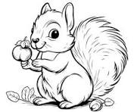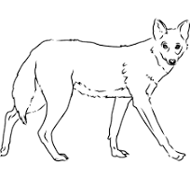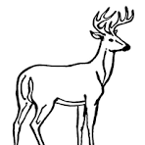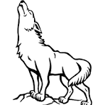
deer wolf squirrel jackal
**************************************************************************************************************
1) Adeer is …………than a squirrel . ( small )
2) A wolf is ……………………….than a squirrel . ( dangerous )
3)Adeer is ………………….. than z jackal . ( big )
4) Adeer is ………………….than a squirrel . ( fast )
★Complete the sentenses :-
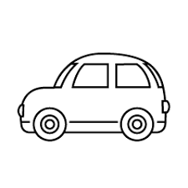 ( big ) 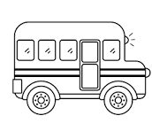
The bus is ……………………………………… the car .

at the top | across | walking up | Picking | planting | looking down | making
1) We'r …………………… fruit.
2) The apples are …………………….. of the tree .
3) I'm …………………………. The ladder.
4) Hassan is walking ……………………….the garden .
5) He's …………………………flowers .
- 6) Muna is …………………avideo .
- 7) I'm …………………………the ladder .
- **********************************************************************************************************
doctor | pilot | teacher | chef

1)…………………..work in airport to fly plane.
2 ) ………………..work in a hospital to help a child with stomachache .
3) …………………. Work I a restaurant to cook delicious lunch .
4) …………………. Work in a school to teach in class .

